# IE 306 SYSTEM SIMULATION HW2 REPORT

masa içeren bir resim

Açıklama otomatik olarak oluşturulduQ1) For the question 1, we collected these data right. For the homework especially, mean, deviation, variance and count are functional statistics.

Figure 1, The Results of Question 1

çizelge, masa içeren bir resim

Açıklama otomatik olarak oluşturulduQ2) For the question 2, firstly we took the input from file and wrote interarrival’s ranks. Then, the interarrivals were sorted. Each interarrival was put into the normal distribution with mean 200 and deviation 50. We used ranks while determining lower bound and upper bound. Finally, we took absolute differences with subtracting our random values from bounds as absolute value. The maximum observed difference is so higher than value from the normal distribution table. Therefore, we reject that the interarrivals were distributed normally with significance level 0.05.

Figure 2, K-S Test Results for Normal Distribution

Q3) We took data, and put them into histograms with 5, 10 and 25 intervals. As we see excel determined interval lengths with range/number of intervals. In low number of intervals, the interarrivals are heaped up the first interval. While number of intervals are increasing, the first interval has most frequency but, distribution in the histogram is less erratic. Actually, histogram graphs show that the interarrivals may be distributed with exponential distribution. Their shapes are similar. You can see the graphs below.

çizelge içeren bir resim

Açıklama otomatik olarak oluşturuldu

Figure 3, Histogram Graph for 5 Intervals

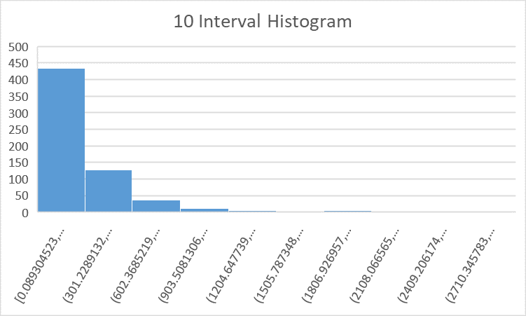

Figure 4, Histogram Graph for 10 Intervals

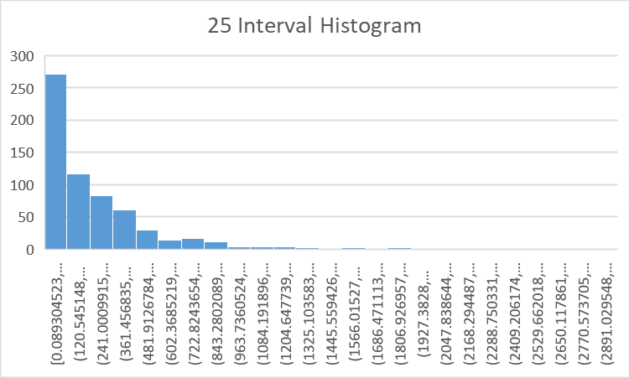

Figure 5, Histogram Graph for 25 Intervals

Q4) We sorted the data, calculated the mean time interval, and calculated value in exponential distribution for each time interval. Finally, put the Chi-Square test and looked the C-S table. Our test statistic is greater than table value so, we reject that the interarrivals are distributed exponentially with significance level 0.05 and mean of data. You can see the results below.

masa içeren bir resim

Açıklama otomatik olarak oluşturuldu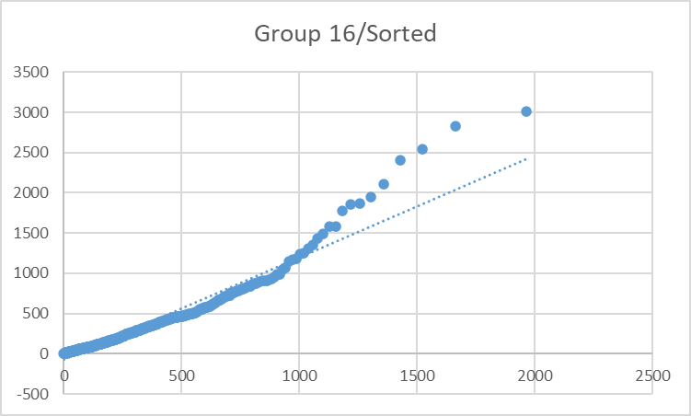Q5)

Figure 6, C-S Results

Figure 7, Q-Q Plot

We took the percentiles and put them into exponential distribution. In x axis, the distribution values, y axis actual data values. In our q-q plot we see that, there is a linear relationship between time intervals and exponential distribution values until data values reach 1000. Then, our data values are higher than distribution values. These values caused data to reject exponential distribution in question 4 probably.

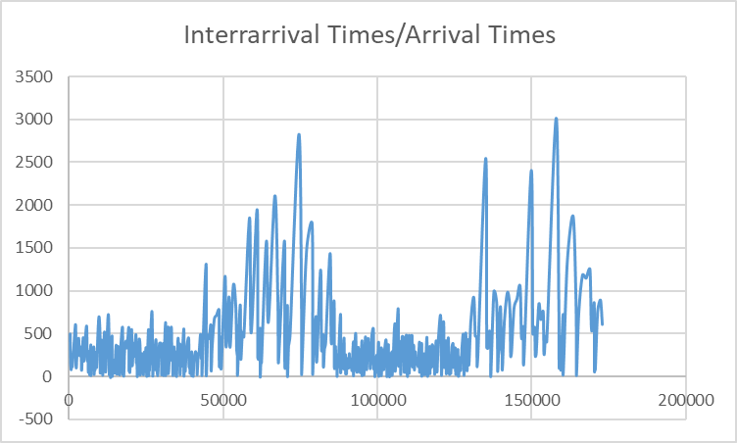Q6)

Figure 8, interarrival/arrival graph

We analyzed the data visually and decided that there is no obvious pattern. The data is a time-varying non-stationary. The arrival rate changes with the intervals of ~43200. First and third interval have a similar mean and same can be said for second and fourth interval.

çizelge içeren bir resim

Açıklama otomatik olarak oluşturulduQ7) Autocorrelation analysis measures the relationship of the observations between the different points in time, and thus seeks a pattern or trend over the time series. Our results are shown below. All values we calculated are not close to 1 or -1. Therefore, we cannot say that data is autocorrelated well. All values are greater than 0, so autocorrelation is positive.

Figure 9, Autocorrelation results

Q8) Since the data is time varying non-stationary, we used the acceptance-rejection algorithm for non-stationary Poisson process variate generation algorithm. We took the mean of different intervals and decided that first and third intervals have mean inter-arrival time of 176.132 seconds while second and fourth intervals have mean inter-arrival time of 635.844 seconds. Since in the given data inter-arrival rate change in ~43200 seconds we decided that in our algorithm we should use these two means in succession repetitively. Then we plotted the inter-arrival times with respect to times of arrival (7th sheet in excel). As it can be seen from the chart below it followed the same pattern of interchanging low-high inter-arrival time.

Figure 10, simulated interarrival/arrival graph for 10 days